The project design for eMart

1. Introduction

eMart is an online eCommerce portal used to search and buy an item online.

1. Use Case

1. Screen Flow

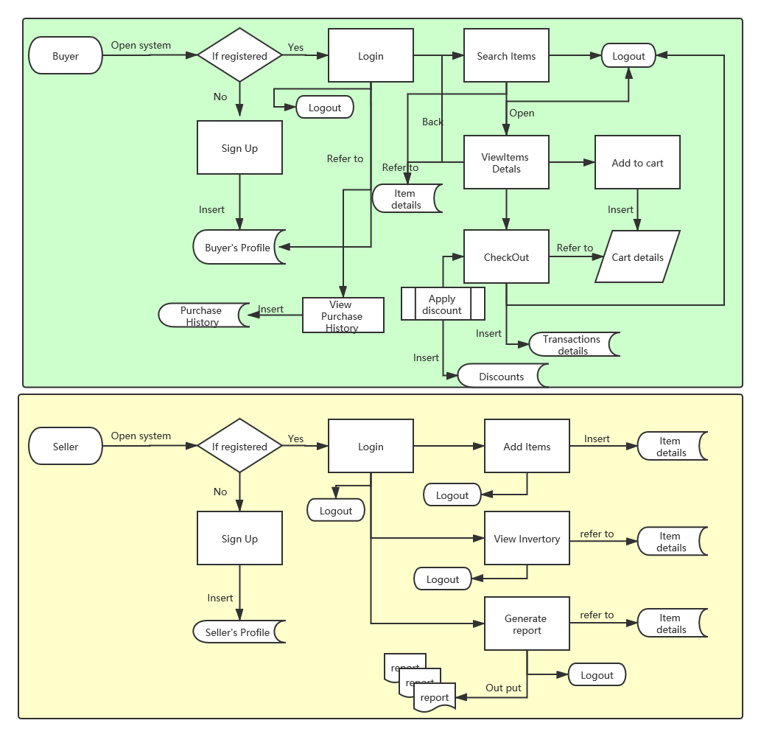

1. Wireframes

Open system

Buyer / Seller login

Buyer’s signup

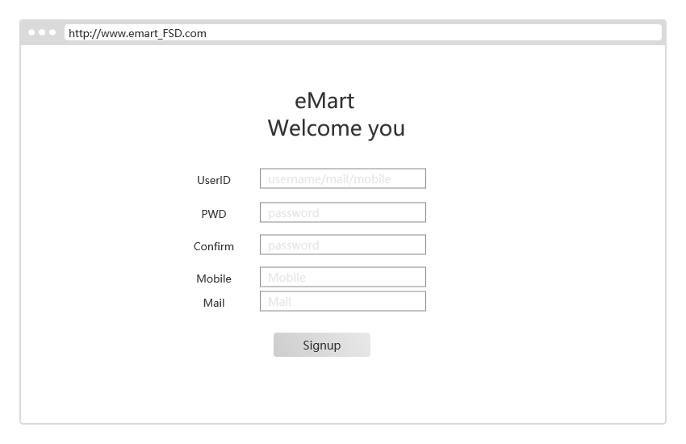

Buyer’s search items

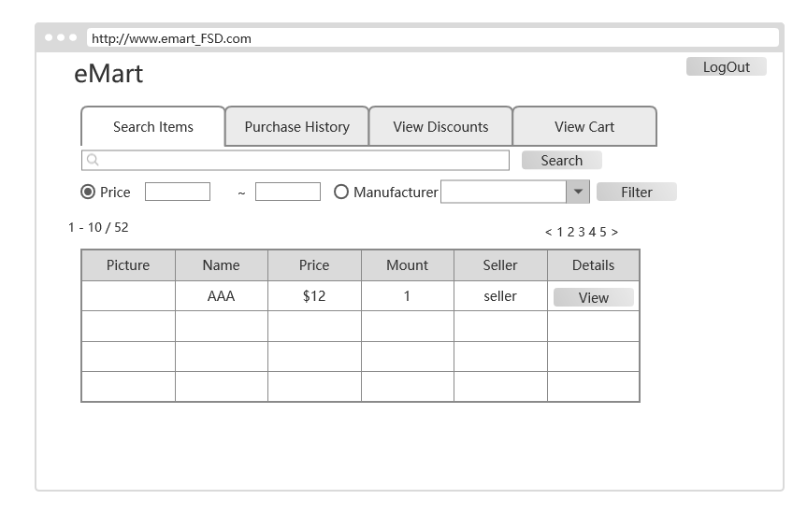

Sorry for others is not prepared. I will upload as soon as possible.

1. Data design

**Buyer:** Buyer’s login and profile details

|  |  |  |  |  |  |
| --- | --- | --- | --- | --- | --- |
| Name | type | PK | NULL | Describe |  |
| ID |  | Y |  |  |  |
| NAME |  |  |  |  |  |
| Password |  |  |  |  |  |
| Email id |  |  |  |  |  |
| Mobile number |  |  |  |  |  |
| created datetime |  |  |  |  |  |

**Seller:** Seller’s login and Selling company details

|  |  |  |  |  |  |
| --- | --- | --- | --- | --- | --- |
| Name | type | PK | NULL | Describe |  |
| ID |  | Y |  |  |  |
| NAME |  |  |  |  |  |
| Password |  |  |  |  |  |
| Company name |  |  |  |  |  |
| GSTIN |  |  |  |  |  |
| brief about company |  |  |  |  |  |
| postal_address |  |  |  |  |  |
| website |  |  |  |  |  |
| emailid |  |  |  |  |  |
| contact number |  |  |  |  |  |